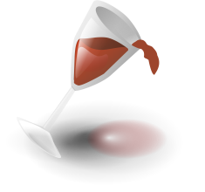
Guess that wine!
WHITES: REDS:
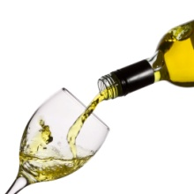1____________________________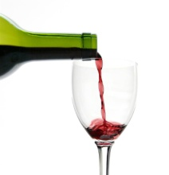 1____________________________
2____________________________ 2____________________________
3____________________________ 3____________________________
4____________________________ 4____________________________
5____________________________ 5____________________________

OPTIONS:
Whites – Chardonnay, Moscato, Pinot Grigio, Riesling, Sauvignon Blanc
Reds - Cabernet Sauvignon, Merlot, Pinot Noir, Syrah, Zinfandel

